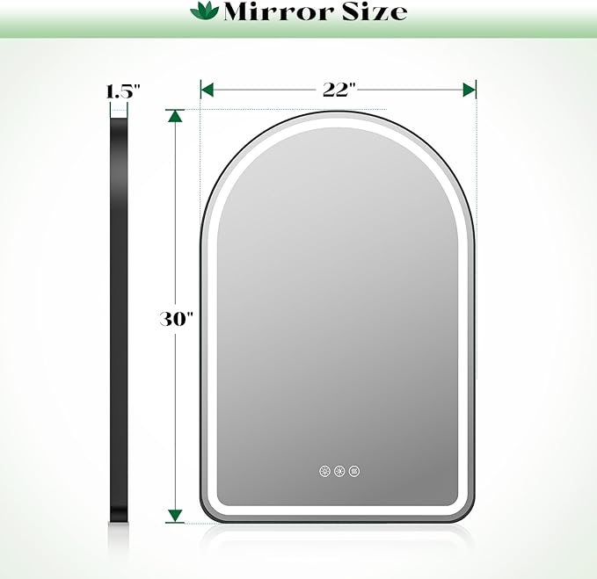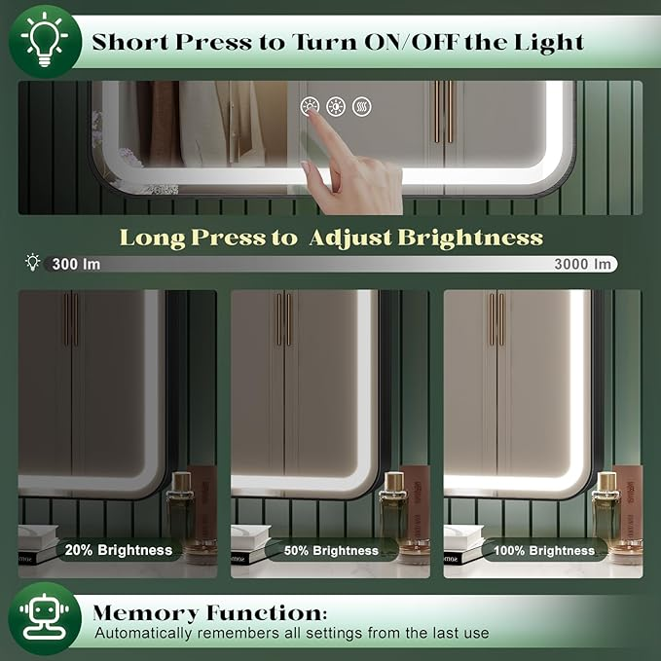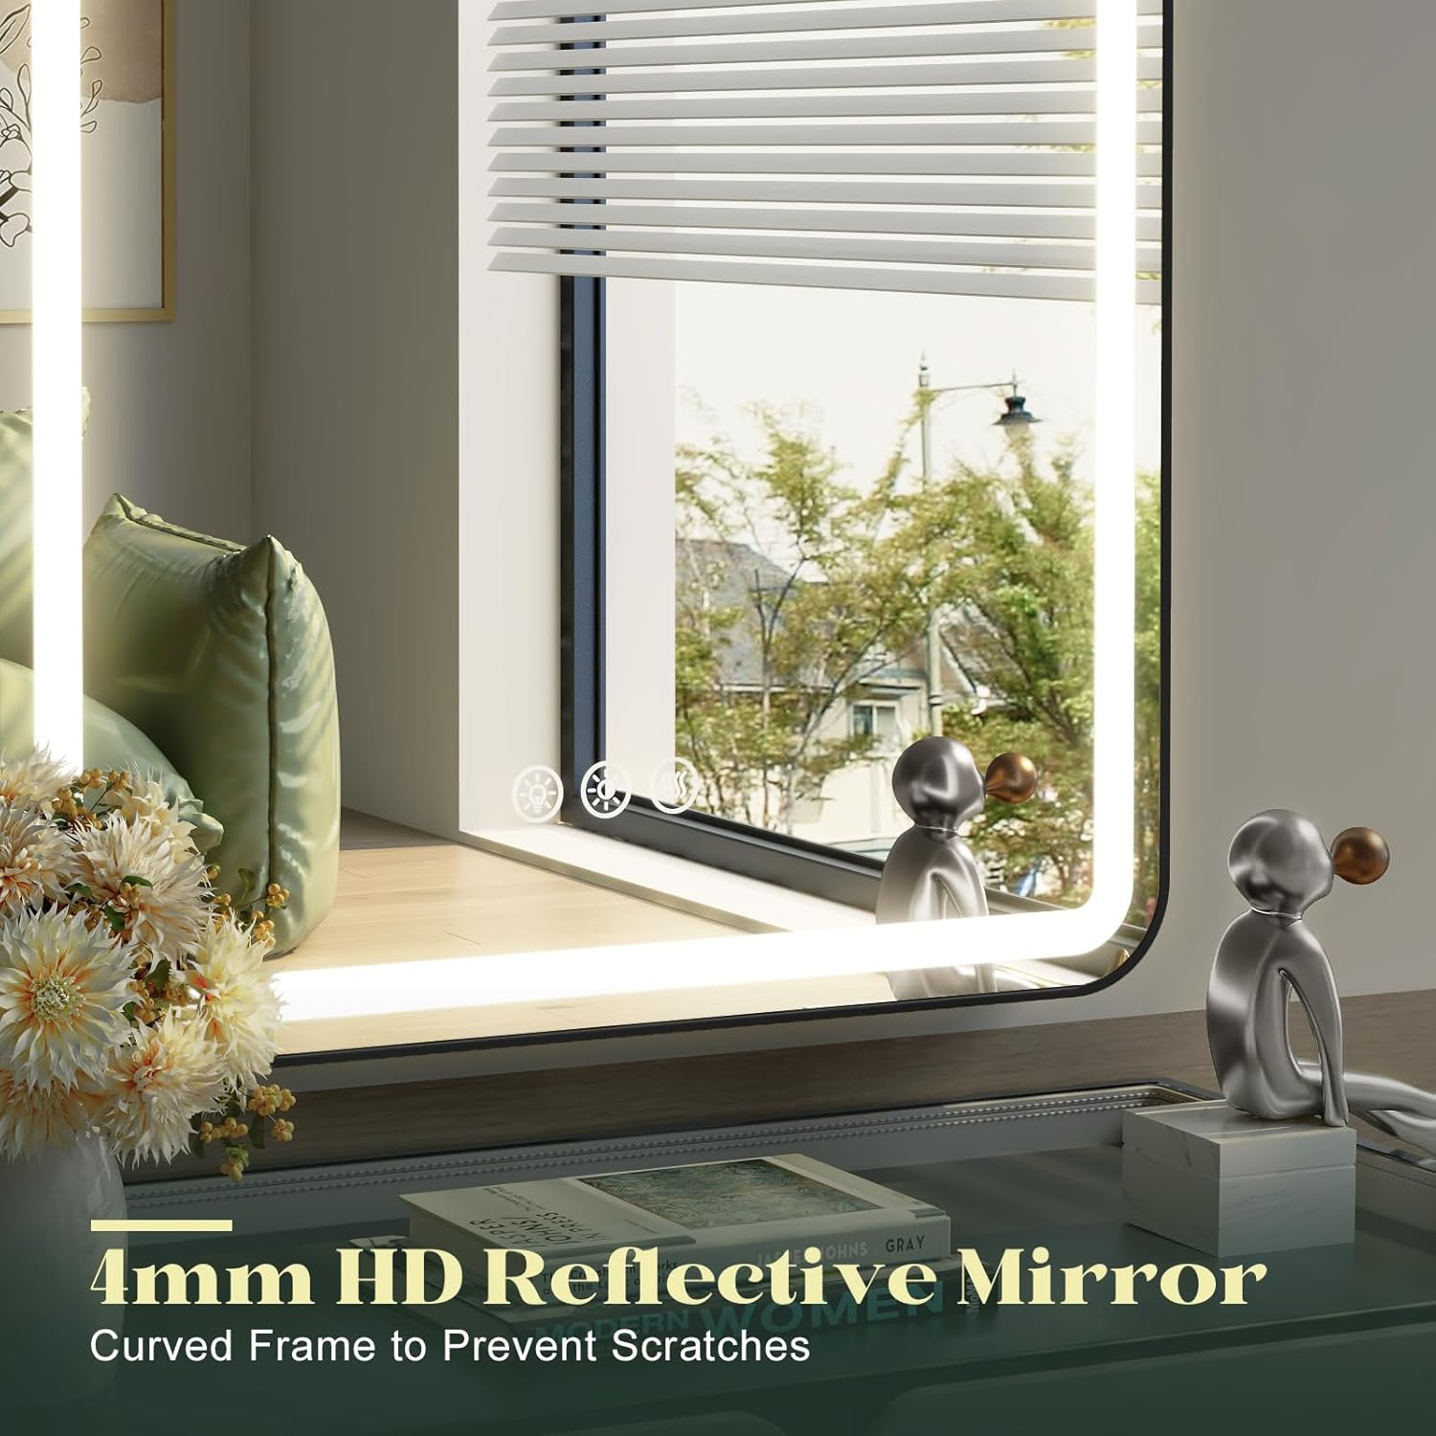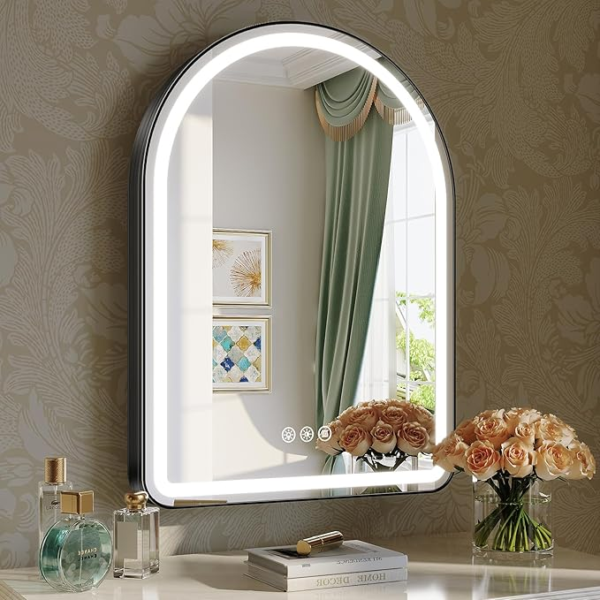

Bathroom Led Mirror, 22"x 30" Black Arched Bathroom Vanity Mirror with Lights, Smart Mirror with Brushed Aluminum Frame for Bedroom with Anti-Fog Dimmable 3 Colors and Lights

**PRODUCT DESCRIPTION:**

Brand Wiserset

Room Type Salon, Bathroom, Living Room, Bedroom, Dining Room

Shape Arched

Product Dimensions 30"L x 22"W

Frame Material Aluminum

**About this item**

* Super Bright Light: Bathroom led mirror has upgraded 240 LED beads/meter, which designed to last up to 25,000 hours. Adjustable brightness up to 3000 lumens, 33% higher than similar mirror. Which is very suitable for makeup, shaving& skincare
* Premium Materials: Lighted bathroom mirror uses 4mm high-definition glass, and the image is clear, distortion-free and not deformed. The brushed aluminum alloy frame is not only lightweight and sturdy, but also fingerprint-resistant
* 3 Color Temperatures: Arched LED mirror for the bathroom offers 3-color temperature adjustment. Tap to cycle through Warm(3000K)/Natural(4200)/Cool(6500K)modes or Long press to smoothly adjust the color temperature —ideal for nighttime skincare (warm), daytime makeup (cool), or ambient lighting(natural)
* Instant Auto Anti-Fog: Activate the defog function 30 minutes before showering to avoid the hassle of manual defog. Auto-off after 1 hour (Save power & Prevent overheating). Bright LED lights for grooming. Stay sharp, not foggy, shadow-free
* Thoughtful Design: Arched bathroom mirror adopts curved frame design to prevent scratches. Long press the anti-fog button(hold 3 seconds) to mute all lights for undisturbed sleep. Memory function can automatically remembers all settings from the last use
* Use & Installation: You can use it as you like in the bathroom, bedroom, cloakroom, makeup room, etc. The package includes all necessary mounting hardware, offering leaned against or wall-mounted installation to perfectly suit your layout.